# Beer Keg Monitoring System

Build your own beer keg monitoring system that keeps track of how many glasses are left in each keg. The entire system costs less than $100 for 5 beer taps.

## Features:

* Tracks level of beer left.
* Measurers temperature.
* Controls Beer freezer temperature
* Provides email and text message notifications.
* Provides local and remote displays via Wi-Fi.
  + Accessible anywhere in the world with Port Forwarding
* Monitors up to 5 beer taps.
* Temperature Stability +/- 0.75 degrees F
* Works with all DHT and/or MCP9808 Temperature Sensors
  + Up to 3 sensors can be used

## Introduction

Currently there are two types of systems to measure how much beer is left in the keg:

1. Flow measuring.
2. Weight of Keg.

Flow measuring systems are cheaper (6 taps about $500) but they have limited utility and you have to clean them every time you clean your beer lines (every 6 weeks).

Weight of keg systems are none intrusive, but very expensive ($1000 for 5 taps). They are not integrated with your entire system.

This system is a low cost eight of keg system.

## System Overview

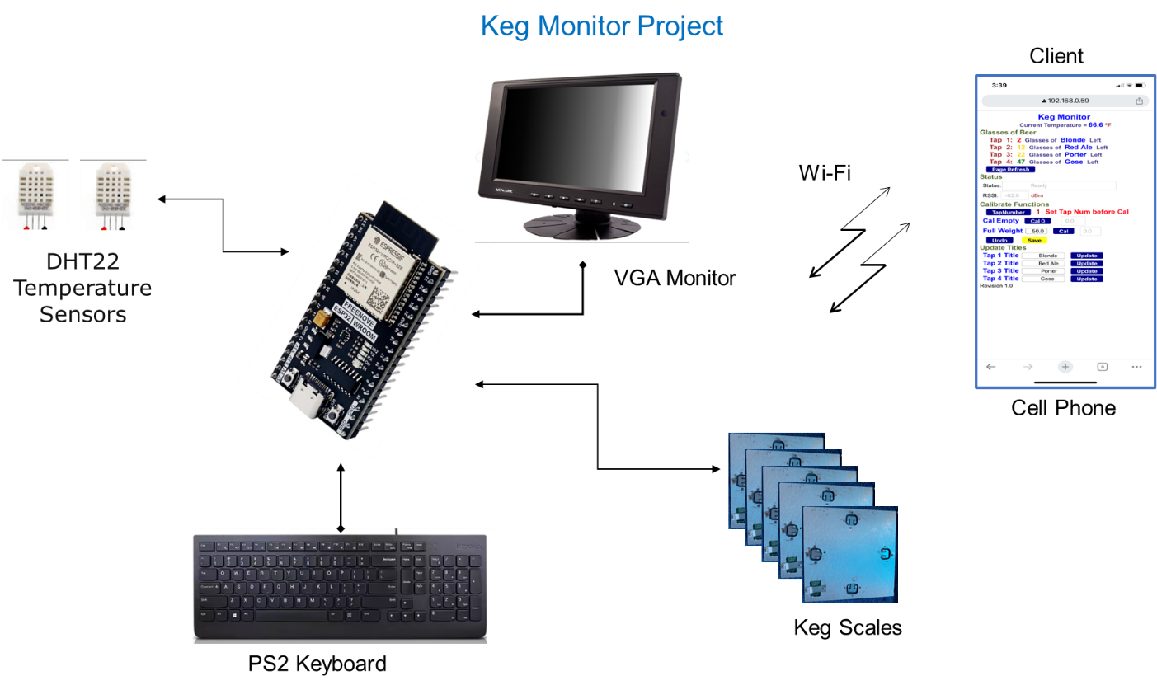

## Bill of Materials

The following is the bill of Materials for the entire system:

|  |  |  |  |  |
| --- | --- | --- | --- | --- |
| Item | Qty | Description | Price | Total |
| 1 | 5 | Scale Plate | $ 2.50 | $ 12.50 |
| 2 | 5 | HX711 Load Cell Amplifier | $ 2.00 | $ 10.00 |
| 3 | 20 | Load Cell | $ 0.80 | $ 16.00 |
| 4 | 1 | PS2 Keyboard | $ 5.00 | $ 5.00 |
| 5 | 1 | VGA Monitor | $ 10.00 | $ 10.00 |
| 6 | 2 | DHT 22/AM2302 Sensor | $ 3.33 | $ 6.67 |
| 7 | 1 | ESP32 Breakout Board | $ 13.00 | $ 13.00 |
| 8 | 1 | ESP32 Development Board | $ 8.50 | $ 8.50 |
| 9 | 1 | VGA Breakout Board | $ 7.50 | $ 7.50 |
| 10 | 1 | PS2 Breakout Board | $ 4.00 | $ 4.00 |
| 11 | 1 | Relay | $ 2.00 | $ 2.00 |
|  |  | Total |  | $ 95.17 |

## Theory of Operation

The theory of operation is quite simple. The data you need is:

1. Scale reading with nothing on the scale (Empty Scale Quanta)
2. Scale reading with a full keg of beer on the scale (Full Scale Quanta)
3. Scale reading of current keg (Current Scale Quanta)
4. Weight of a full keg (Full Keg Weight)
5. Weight of an empty keg (Empty Keg Weight)

The system automatically measures the first three items, all you need to do is measure the full key weight and the empty keg weight. I just use a bathroom scale.

Reading Per Ounce = (Full Scale Quanta – Empty Scale Quanta) / (Full Keg Weight * 16)

Current Ounces = (Current Scale Quanta – Empty Scale Quanta) / Reading Per Ounce

Glasses = (Current Ounces – Empty Keg Weight) / 12 Ounces per glass